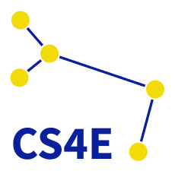
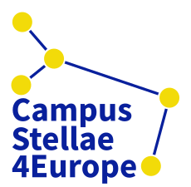
VISUAL PROJECT IDENTITY

PROJECT OFFICIAL LOGOS
The official logos of Campus Stellae 4 Europe are inspired in Canis Major, the constellation that contains Sirus. This is the brightest star in the night sky, and indicates the Way of Stars: from ancient times pilgrims followed the Milky Way, which flows into Canis Major constellation, on their path to reach Santiago de Compostela.

PROJECT OFFICIAL FONT
Project official font is Source Sans Pro. It’s an open source font that can be downloaded free to use from: https://fonts.google.com/specimen/Source+Sans+Pro

PROJECT OFFICIAL COLORS
Project official colors are:
- Blue. RGB(9, 32, 156)
- Yellow. RGB(242, 219, 9)

DOCUMENTS TEMPLATE
For documents creation, partners will use the templates based on this Project Visual Identity, where header, footer, font, text styles and other elements are already set:
- Microsoft Word: 00.CS4E.TEMPLATE.HOR.dotx | 00.CS4E.TEMPLATE.VER.dotx
- Microsoft PowerPoint:
- Microsoft Excel:
- Google Docs: 00.CS4E.TEMPLATE.gdoc
- Google Slides:

